Day 7 Coding Assignment — MongoDB Data Modeling and CRUD Operations
User Stories and Tasks User Story 1 —
Database Setup and Data Modeling As a developer, I need to design the MongoDB collections to efficiently represent books, authors, and reviews in a NoSQL structure.
Tasks:
1. Create a new MongoDB database named BookVerseDB.
2. Define the following collections and structure them using proper schema modeling principles:
○ Authors: { _id, name, nationality, birthYear }
○ Books: { _id, title, genre, publicationYear, authorId, ratings: [ { user, score, comment } ] }
○ Users: { _id, name, email, joinDate }
3. Ensure one-to-many relationships are implemented using references (authorId) and embedded documents (ratings).
4. Insert a few sample documents (at least 3 authors, 5 books, 3 users).
Concepts Covered: NoSQL structure, MongoDB data modelling
Mongosh Screenshots –
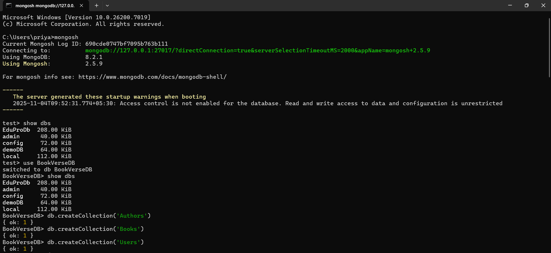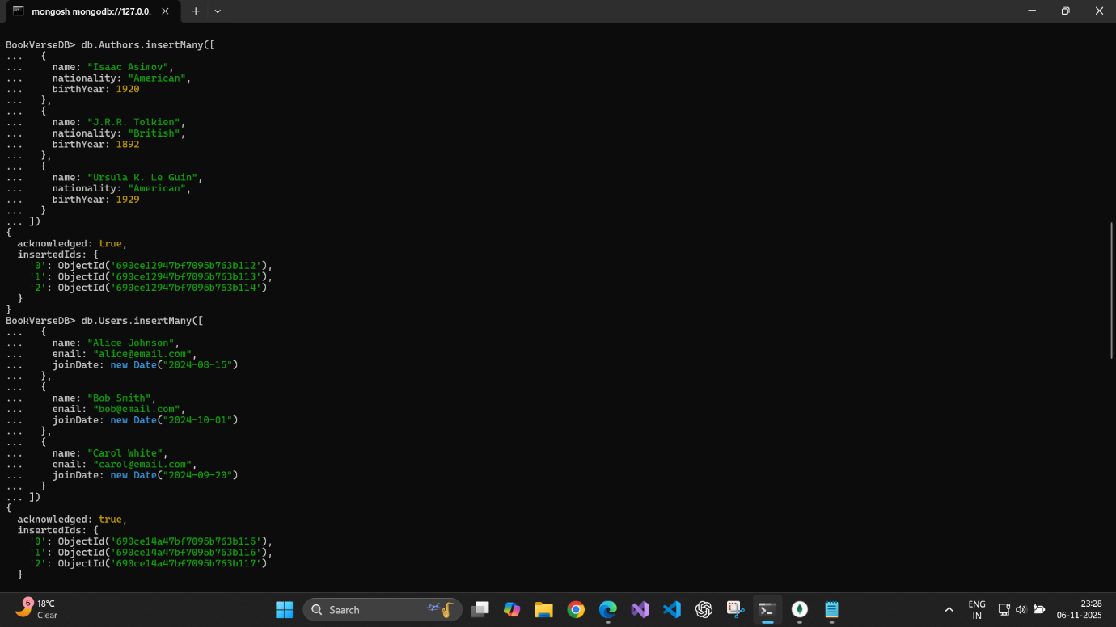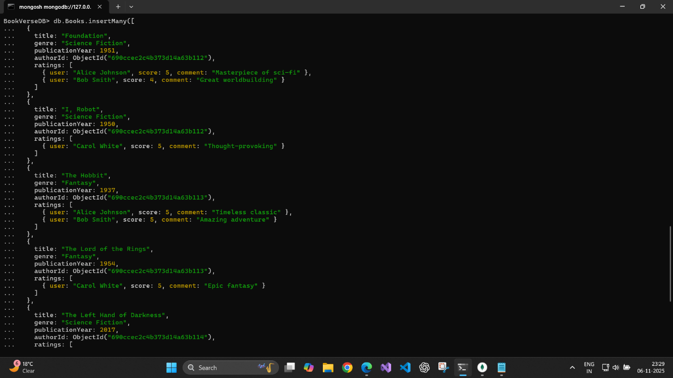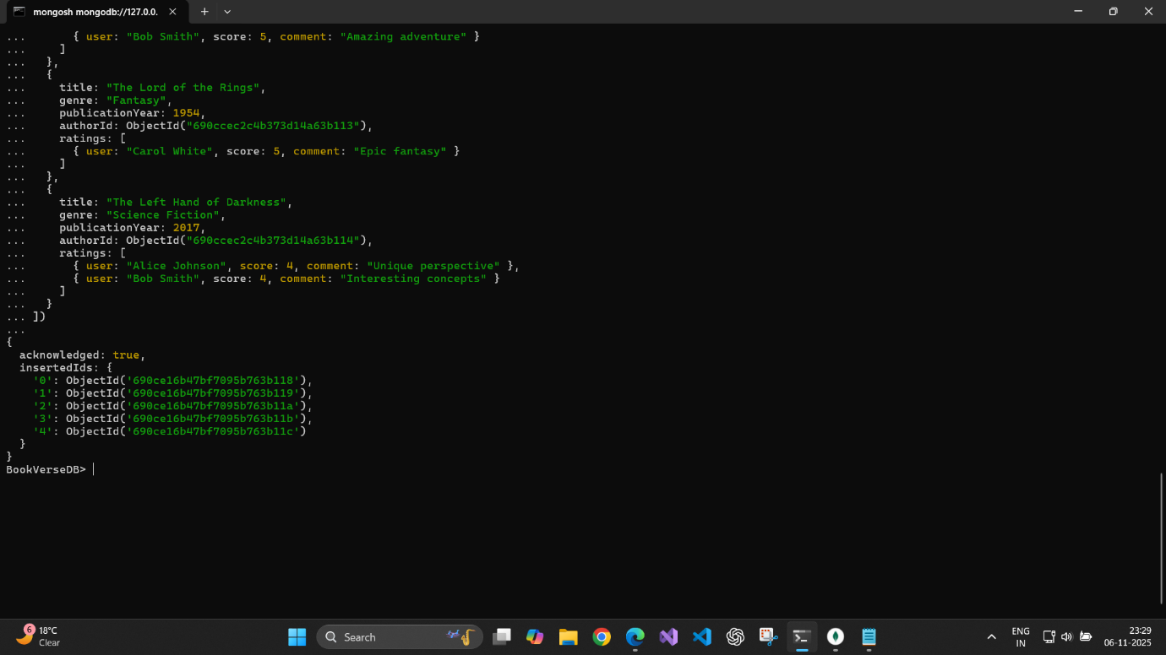

User Story 2 —
CRUD Operations As a backend developer, I need to perform basic Create, Read, Update, and Delete operations on the collections.
Tasks:
1. Insert new users and books into the database.
2. Retrieve all books of the genre “Science Fiction”.
3. Update the publicationYear of one book.
4. Delete one user record from the collection.
5. Add a new rating to a book document using the $push operator.
Concepts Covered: CRUD operations, update modifiers
Mongosh Screenshots –

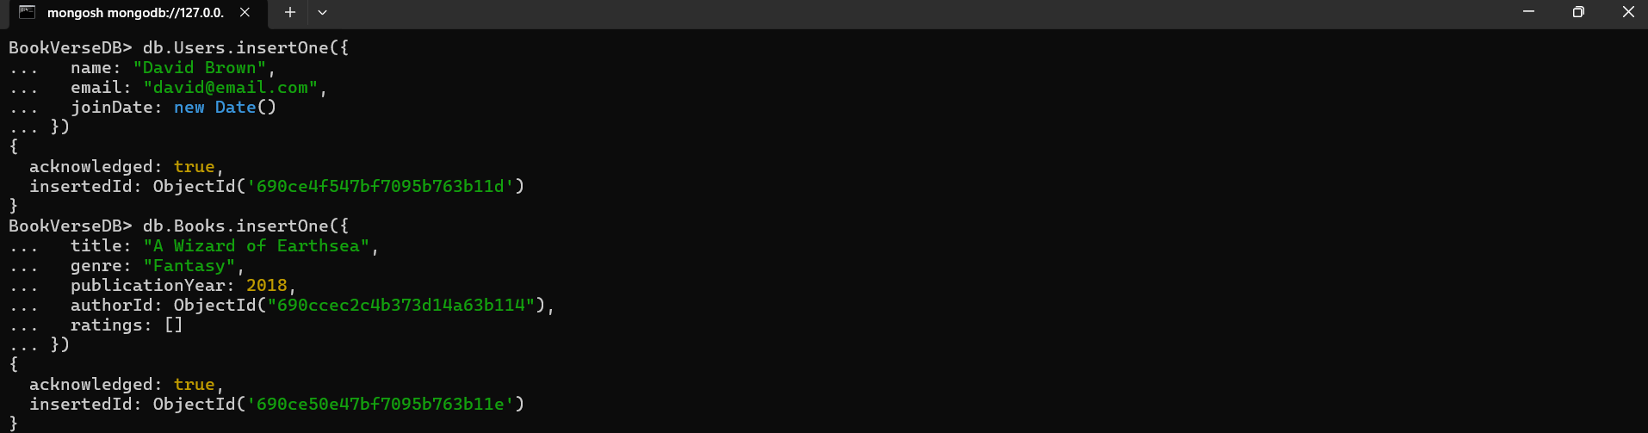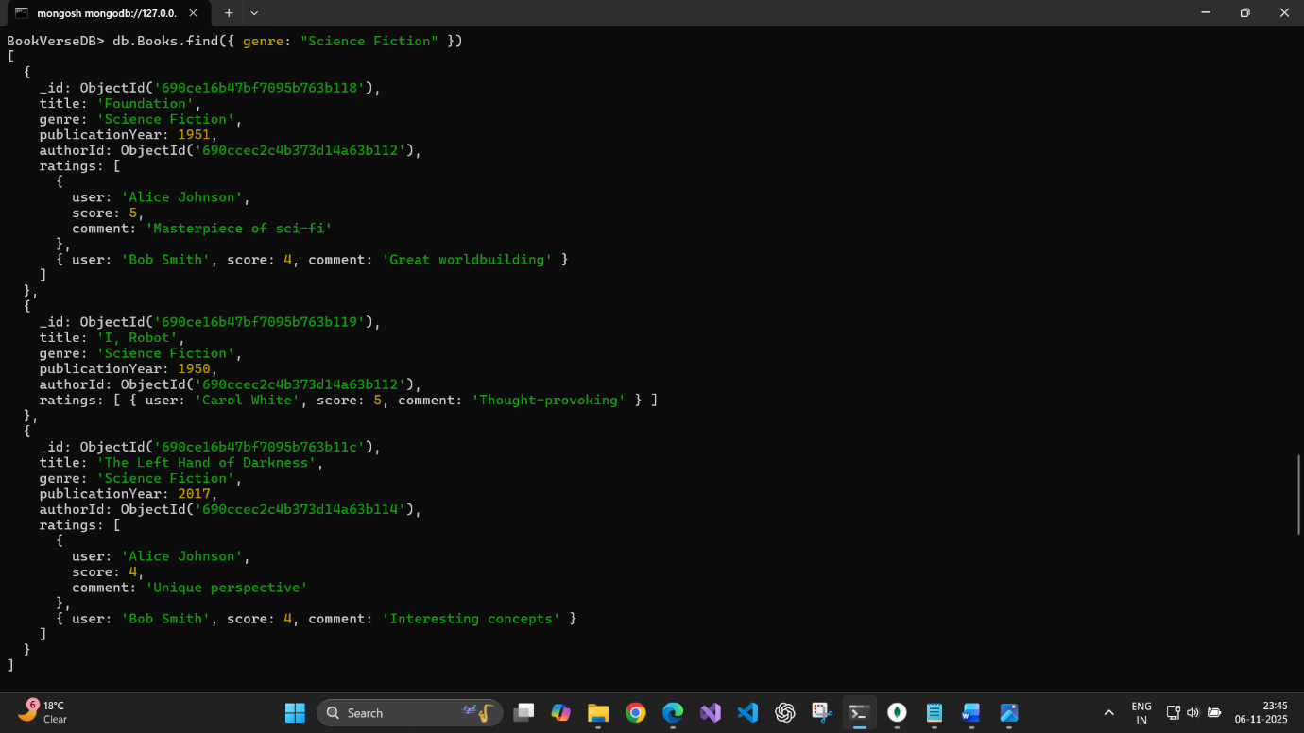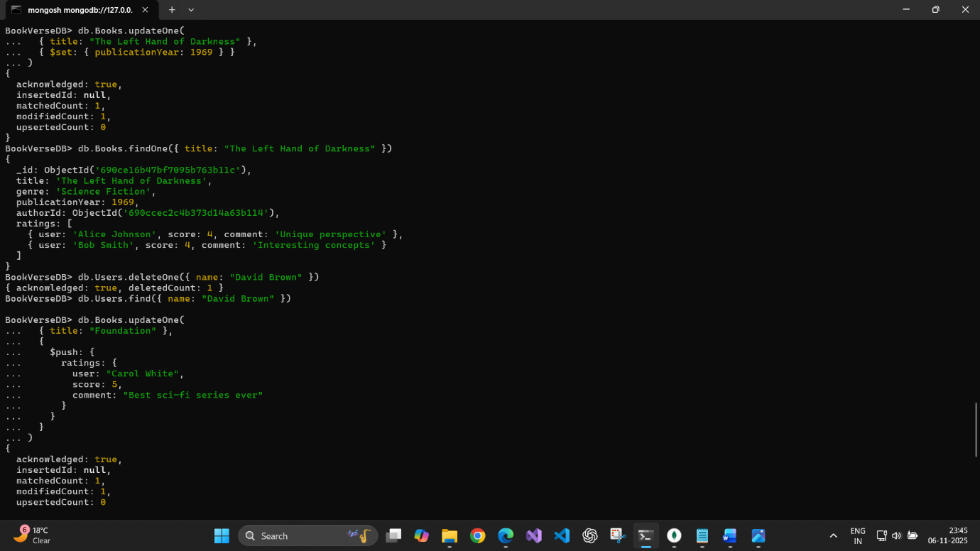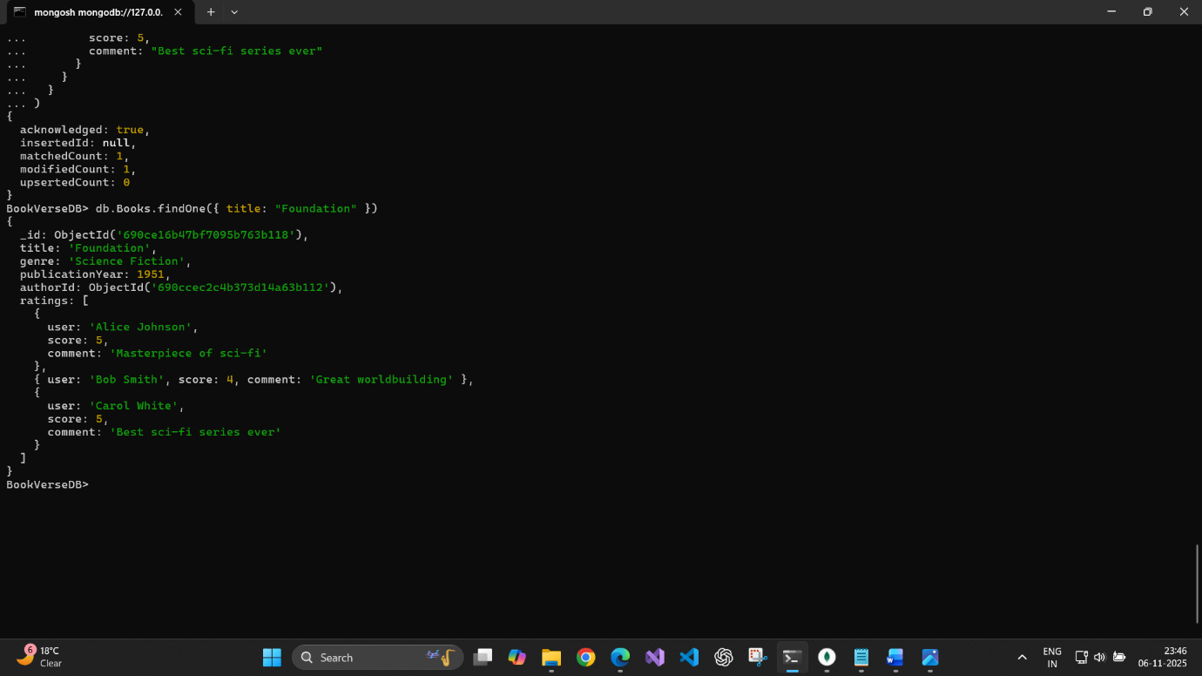

User Story 3 —
Querying and Filtering Data As an application developer, I need to query data for the web interface based on filters.
Tasks:
1. Retrieve all books published after 2015.
2. Find authors who have written books in the “Fantasy” genre.
3. Retrieve all users who joined within the last 6 months.
4. Find books with an average rating greater than 4.
Concepts Covered: Query filters, conditional operators, nested field access

Mongosh Screenshots –

